Lab 02 – Basics of HTML

**CIS 201 – Fundamental of web design**

**Al Yamamah University, COEA, AlKhobar, SA**

**Prepared by: Dr. Roxane Mallouhy**

|  |  |  |
| --- | --- | --- |
|  |  | Objectives / Statement Purpose |

* To introduce students to the core concepts of web design using HTML.
* To provide practical experience in structuring and styling web pages using HTML tags and elements.
* To enhance understanding of HTML through exercises involving hyperlinks, images, tables, and form elements.
* To develop skills in creating and organizing content on web pages using lists and table structures.

|  |  |  |
| --- | --- | --- |
|  |  | Activity Outcomes |

This lab teaches you the following topics:

* Understanding the basic structure and organization of an HTML document.
* Creating and styling both ordered and unordered lists, including nested lists.
* Embedding images and using them effectively in web pages.
* Constructing tables with various attributes, including rowspan and colspan.
* Designing a basic web form that includes text input fields, text areas, radio buttons, dropdown menus, and action buttons like "Reset" and "Submit."

**Note**: performing given home activities or extra programming is highly recommended to improve your understanding, capability, and programming skills.

Lab Activities

2

Lab 02 – Basics of HTML

**Lab Assessment**

|  |  |  |  |  |  |  |  |  |  |  |  |  |  |  |  |  |  |  |  |
| --- | --- | --- | --- | --- | --- | --- | --- | --- | --- | --- | --- | --- | --- | --- | --- | --- | --- | --- | --- |
| |  |  |  | | --- | --- | --- | | **Student Name** |  |  | |  |  |  | | **Student ID** |  |  | | |  |  |  | | --- | --- | --- | | **Section** |  |  | |  |  |  | | **Date** |  |  | |

|  |  |  |
| --- | --- | --- |
|  |  | Activity 1: |

Write an html file that looks as follows:

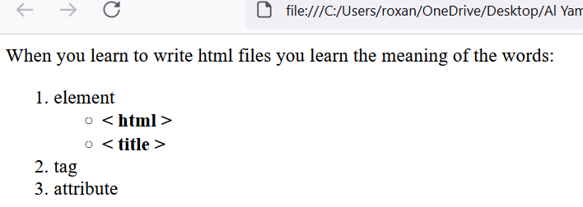

|  |  |  |
| --- | --- | --- |
|  |  | Activity 2: |

Write an html file that contains the following nested lists. The html file contains both ordered and unordered lists. Add the image as well.

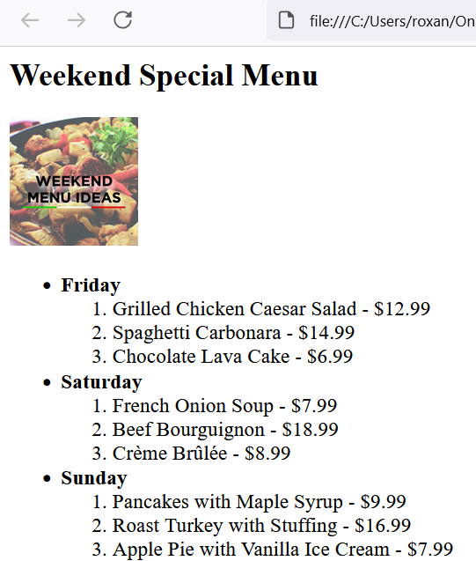

|  |  |  |
| --- | --- | --- |
|  |  | Activity 3: |

Write an html file that has the following table:

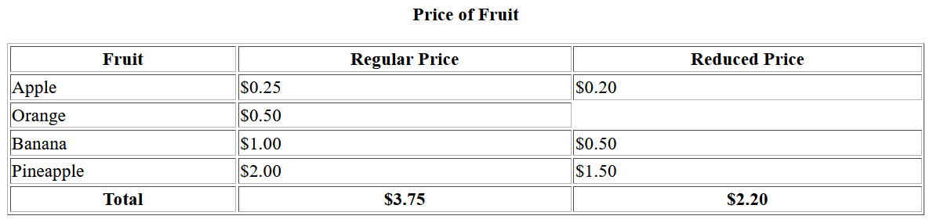

|  |  |  |
| --- | --- | --- |
|  |  | Activity 4: |

Write an html file that has the following table:

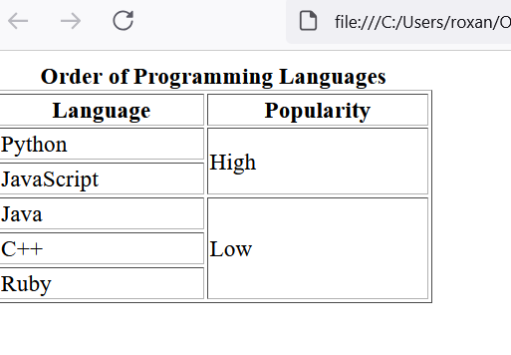

|  |  |  |
| --- | --- | --- |
|  |  | Activity 5: |

Make a table using colspan

